https://www.coursera.org/learn/python/lecture/LGrLo/1-3-python-as-a-language
https://www.coursera.org/specializations/python
https://www.youtube.com/watch?v=fvhNadKjE8g&list=PLlRFEj9H3Oj7Bp8-DfGpfAfDBiblRfl5p&index=2
Logged in as: 259f764a1647d29f18da93d5df1a9f4f germancb79@gmail.com German Cordoba
https://www.py4e.com/tools/pythonauto/?PHPSESSID=1a3da48b4cd1a231b9f66aa593e91092
https://www.python.org/downloads/
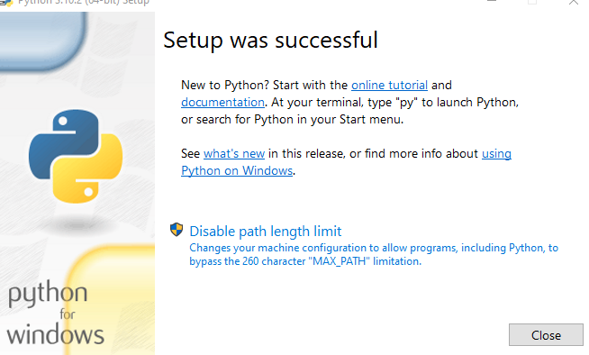
https://atom.io/
Command Line -> cmd enter Python aparece >>>
CTRL z para volver a cmd
Editor instalado: Atom
Herramienta RECORTES (Snipping tool) capturar pantallazos
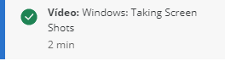
Notepage.png
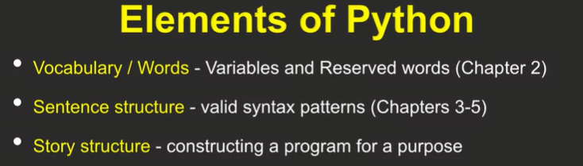

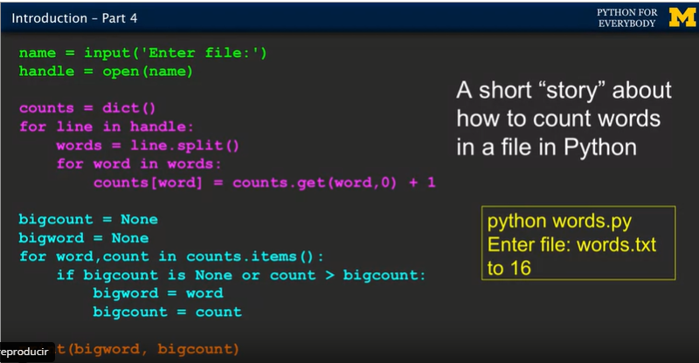
Reserve words
